**Majors**

**B.A. English**: Explore the human condition through the lens of literature and language. With an emphasis on critical thinking, research, and oral expression, students gain a diverse skill set that is transferable to many industries and professions.

**B.S. English Education**: Inspire the next generation of communicators! This program provides a pathway to gaining a New York State initial certification to teach English in grades 7-12.

**B.A. Writing**: Study and practice the craft of writing with the study of literature, theater, television, and communication arts. The writing degree program allows for the development of skills in creative, professional, technical, journalistic, and literary writing.

**Minors**

English Ed • Film Studies •

Literary Studies • Writing

Find

Your

Voice

**The English Department**

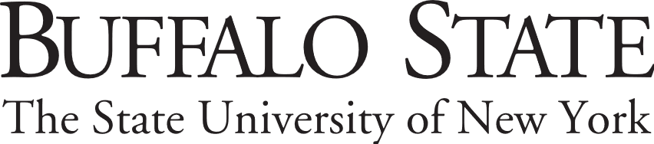

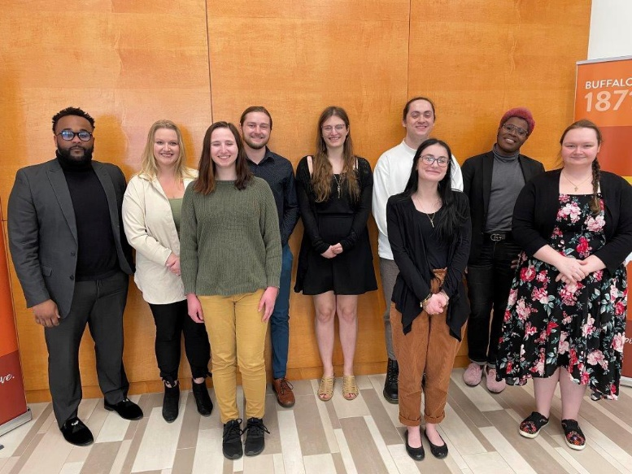

**Scan the code** for all department opportunities, and program information, and **get in touch!**

**Contact Us!**

**Buffalo State**

**1300 Elmwood Ave Ketchum Hall 213**

**Buffalo, NY 14222**

**Phone: (716) 878-5417**

**Fax: (716) 878-4939**

**english@buffalostate.edu**



**Our graduates are finding success in diverse fields. Below are just a few job titles held by our English program graduates.**

**TV Reporter/Anchor**

**Technical Writer**

**Lawyer**

**English Teacher (K-12)**

**Grant Writer**

**Journalist**

**Legislative Assistant**

**Librarian**

**Lobbyist**

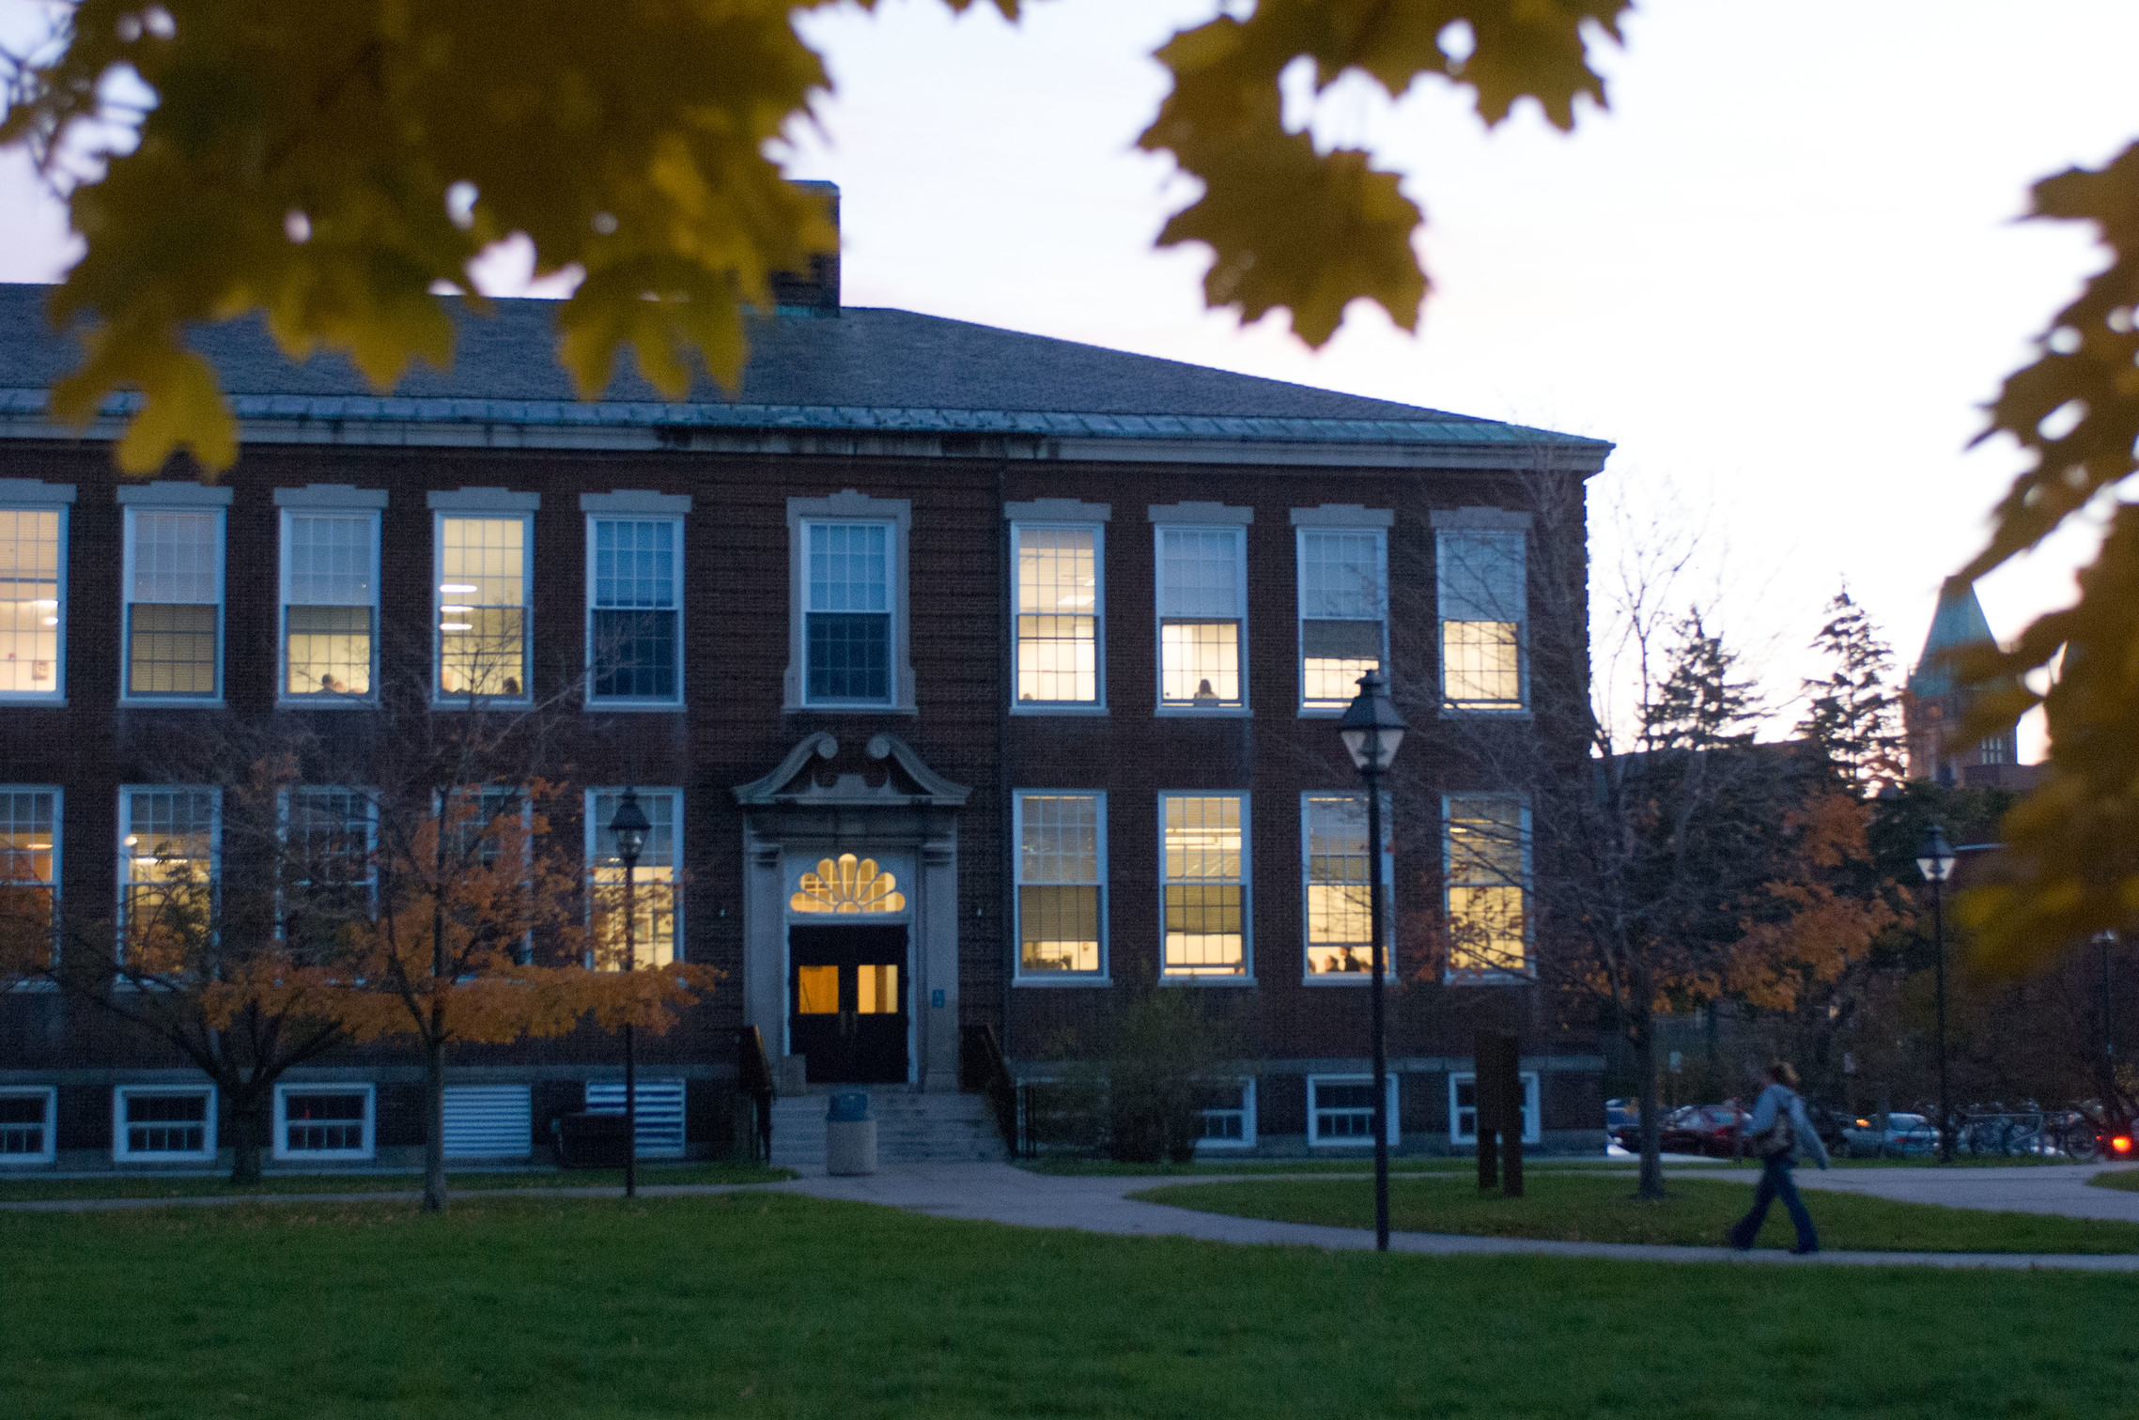

**Certificate Programs**

**Technical Writing**: Hone your ability to analyze and interpret technical information for a variety of audiences.

**English Education**: This postbaccalaureate program leads to eligibility for New York State initial certification

**Graduate Programs**

**English Education**

**(7–12; M.S.Ed.)**

This graduate program provides flexibility in meeting individual interests while ensuring a broad understanding of the various aspects of teaching English. The program develops highly qualified teachers who are prepared to exercise leadership as accomplished professional educators.

**English MA**

The Master of Arts in English program builds upon students’ undergraduate work in English by offering the opportunity to study several different areas of concentration in depth. It also serves as an excellent preparatory program for doctoral-level study in English.

**Why English at Buffalo State?**

student-teacher ratio of 20:1 • historic campus setting • over 150 years of excellence • student-run literary and arts journal • scholarship opportunities • renowned faculty • **and so much more!**

**Our Mission**

We recognize the contemporary demand for analytical, literate, and creative thinkers. We strive to empower students, through the study of literature and language, to use these skills to contribute to their workplaces and communities and throughout their lives as lifelong learners.

